Lab Report No 7

Implementation of autocorrelation/cross correlation
Digital System Processing



Submitted By:
[Huzaifa Shahbaz]
[21-CE-009]

Submitted to:
Engr. Hareem Khan
Dated:
2nd,April,2024

Department of Computer Engineering,
HITEC University, Taxila
Lab Example No 1:

Solution:
Brief description (3-5 lines)
Auto Correlation Function:
Auto correlation function is a measure of similarity between a signal & its time delayed version. It is represented with R(k).
The auto correlation function of x(n) is given by 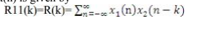

Cross-correlation Function:
Cross-correlation is a measure of similarity between two signals as a function of the time delay applied to one of the signals. It is commonly used in signal processing and communication systems to identify time delays and patterns in signals. In this section, we will discuss the formal theory and provide the Python
code to compute the cross-correlation of two signals.The cross-correlation between two discrete-time signals x(n) and y(n) is defined as:
R_xy(m) = sum_n [ x(n) * y(n+m) ]
where m is the time shift, and R_xy(m) is the cross-correlation of x and y at time shift m.
The code
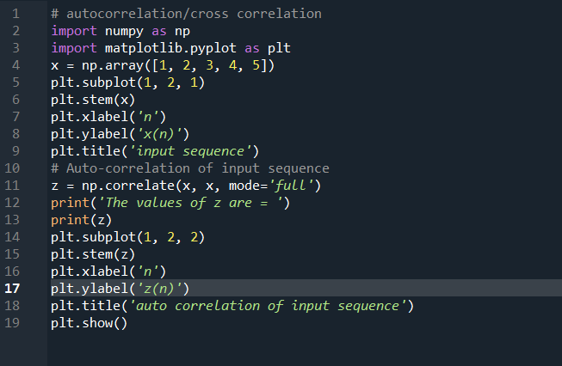
The results (Screenshot)
Graph:
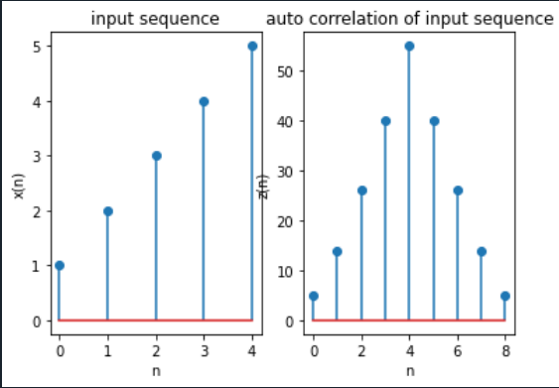
OUTPUT:
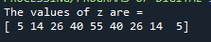
Lab Example No 2:

Solution:
Brief description (3-5 lines)
Auto Correlation Function:
Auto correlation function is a measure of similarity between a signal & its time delayed version. It is represented with R(k).
The auto correlation function of x(n) is given by 

Cross-correlation Function:
Cross-correlation is a measure of similarity between two signals as a function of the time delay applied to one of the signals. It is commonly used in signal processing and communication systems to identify time delays and patterns in signals. In this section, we will discuss the formal theory and provide the Python
code to compute the cross-correlation of two signals.The cross-correlation between two discrete-time signals x(n) and y(n) is defined as:
R_xy(m) = sum_n [ x(n) * y(n+m) ]
where m is the time shift, and R_xy(m) is the cross-correlation of x and y at time shift m.
The code
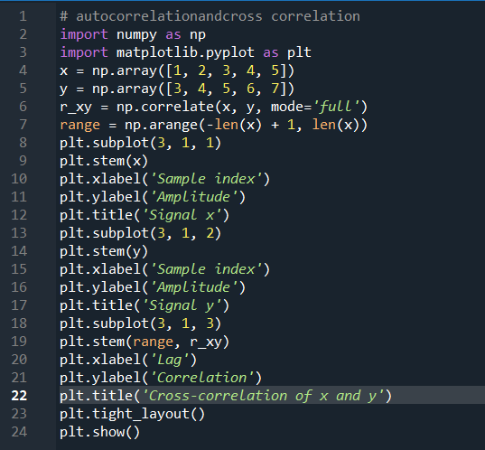
The results (Screenshot)
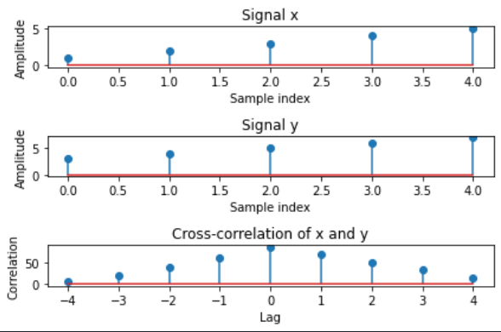
Lab Task No 1:

Solution:
Brief description (3-5 lines)
Find the cross correlation of the sequences
x(n)= {3,5,1,2} and h(n)= {1,4,3}
The code
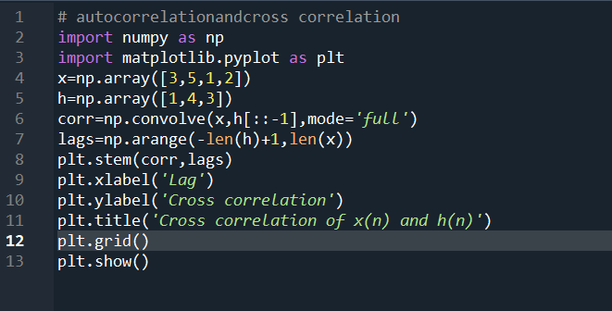
The results (Screenshot)
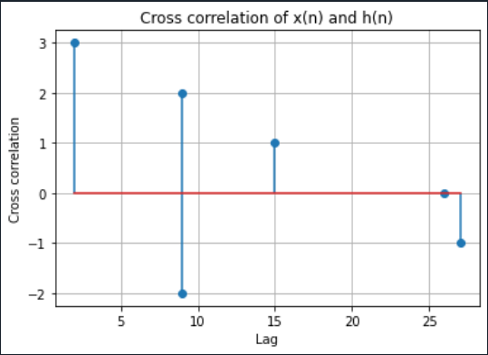
Lab Task No 2:

Solution:
Brief description (3-5 lines)
Find the cross correlation of the sequences
x(n)={2,3,1,4} and y(n)={1,3,2,1}
The code
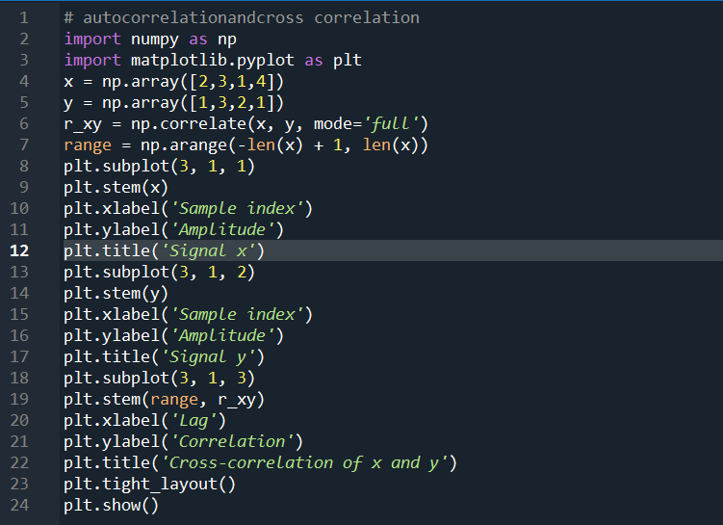
The results (Screenshot)
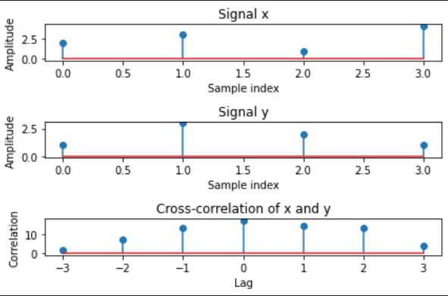
Lab Task No 3(a):

Solution:
Brief description (3-5 lines)
Find the autocorrelation of the sequences
x(n)= {1,3,0,4}
The code
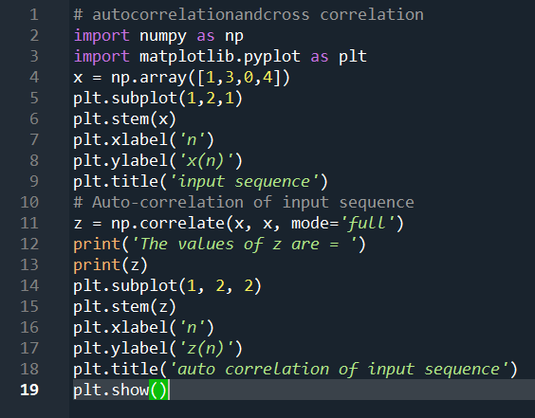
The results (Screenshot)
Graph:
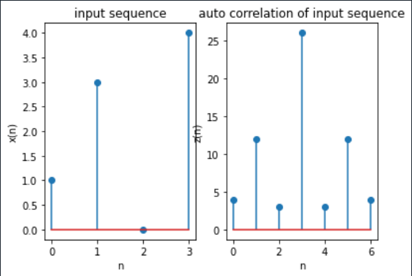
OUTPUT:
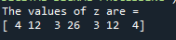
Lab Task No 3(b):

Solution:
Brief description (3-5 lines)
Find the autocorrelation of the sequences
y(n)= {2,1,-2,1}
The code
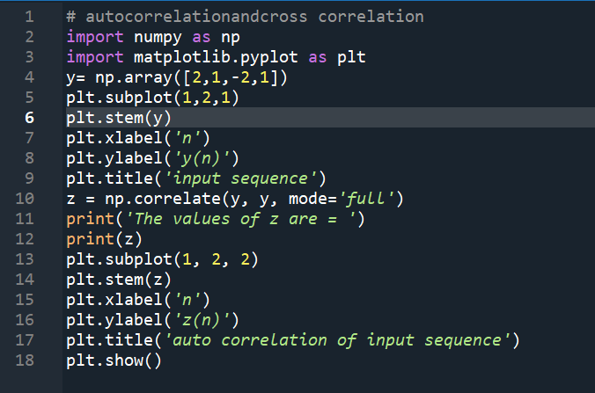
The results (Screenshot)
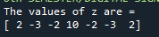
Graph:
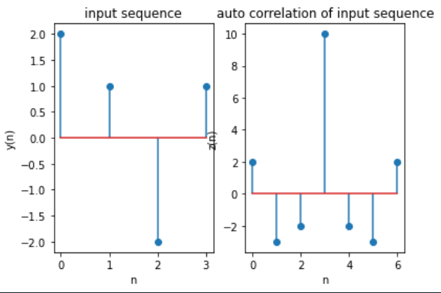
Lab Task No 2:

Solution:
Brief description (3-5 lines)
Find the discrete periodic cross correlation Rxyp(n) and Rxyp(n) of the whose first period is given by:
x(n)= {1,3,0,4} and y(n)= {2,1, -2,1}
The code
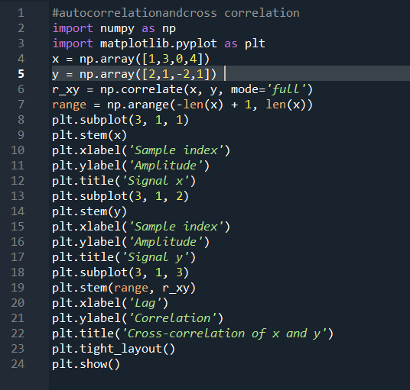
The results (Screenshot)
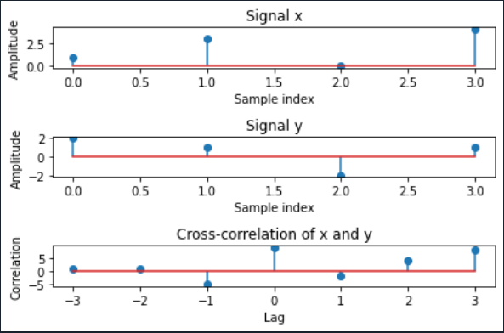

Conclusion
In conclusion, Autocorrelation measures a signal's similarity to itself over time, aiding in identifying periodic patterns or dependencies within data. Cross-correlation compares two signals to find similarities or correlations between them, useful for identifying relationships between different data sets or signals. Both techniques are valuable in signal processing, time series analysis, and various fields where understanding temporal relationships is crucial.

